#### 

#### **Graph ADT**

* **Data**: all vertices, all edges, and the structure to maintain relations between vertices and edges.
* **Functions**:
  + insert vertex/edge,
  + remove vertex/edge,
  + find incident edges,
  + check if two vertices are adjacent, and
  + In case of directed graph find origin/destination.

#### **Graph implementation 1: Edge List**

* **Vertex collection**: Use a hash table (find/remove/insert will be O(1)).
* **Edge collections**: Use a linked list (hash table is not good because we have many collisions (no random distribution, violates SUHA) )
* **Running time**:
  + Insert vertex → we are using hash table where insert takes O(1) time.
  + Remove vertex → removing from hash table takes O(1), but we need to remove incident edges which means we need to loop over edges list. We have m edges sok8it will take O(m) \i
  + areAdjacent → again, we need to loop over the edge list which takes O(m) time.
  + InsertEdge→ add edge to edge list by adding to the front so it takes O(1)
  + incidentEdges → O(m).
  + The running times seem linear however, we know that the relationship between number of nodes and the number of edges could be $n^{2}$; which means O(m) could in fact be O($n^{2}$)

**Graph implementation 2: Adjacency Matrix**

* Maintain a hash table of vertices and a list of edges.
* Add an $n×n$ matrix → store a pointer to the edge in edge list for every index in the matrix where the two vertices are adjacent.

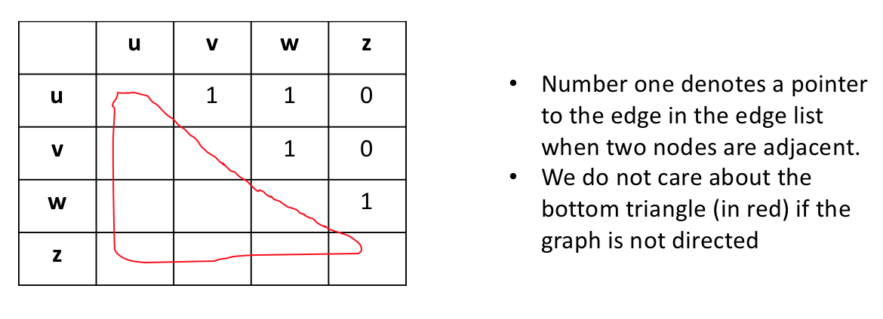

* + **Insert data into the matrix** 
    - If the table is full, we need to double the size in both dimensions which takes O($n^{2}$) time.
    - We have to expand every *n* inserts, thereby on average resizing is O(n) amortized → O*(n). Overall, insertion takes O*(n).
  + **Remove a vertex**
    - Remove from hash table → O(1).
    - Remove instance edges: Loop over all rows and columns of that vertex which takes O(n)
      * We will also have an awkward gap in the middle of the matrix after removing a row and a column. So we swap with the empty row/column with the last row/column.
    - Total running time is O(n) + O(1) = O(n).
  + incidentEdges→ we need to loop over row/column which takes O(n).
  + InsertEdge→ O(1)
  + Find/check adjacent vertices takes O (1) → just a table lookup.
  + **Space** complexity is O($n^{2}$).

##### **Implementation 2 runs in either O(1) or O(n), while Implementation 1 runs in either O(1) or O(m). Which one is better?**

* + The tradeoff is depends on the data. If the graph is not connected, then the Implementation 1 is better even though it seems bad if we look at the worst case running time.
  + Therefore before we decide on the specific implementation choices, we need to consider what our data set looks like.